Workshop Report

Members:
Christian Macías
Diego Alfonzo
Jefferson Saltos
Ayman El Salous
Danilo Drouet

Repository: https://github.com/ChristianMacias0/Workshop_Continuous_Integration_pongping.git

Rols
Christian Macías: Configured Jenkins, installed ngrok, created the repository and uploaded code. DevOps Engineer.
Diego Alfonzo: Developer and Tester
Jefferson Saltos: Developer
Ayman El Salous: Developer
Danilo Drouet: Developer and Tester

INTRODUCTION
In modern software engineering, the traditional method of merging code at the end of a development cycle introduces significant risks, including catastrophic merge conflicts and hidden regressions. This project demonstrates the practical application of Continuous Integration (CI) as a fundamental remedy to these challenges.
By establishing a centralized, automated pipeline, this workshop simulates a real-world enterprise environment. The core objective is to integrate individual code contributions from multiple developers into a single stable repository, enforcing strict code style guidelines through linting and functional verification via automated testing frameworks before any pull request can be merged.

The technical implementation of the workshop was executed in three sequential phases: environment setup, application development with testing, and automated orchestration.

DEVELOPMENT
- Infrastructure and Environment SetupRepository Lifecycle:
A centralized Git repository named Workshop_Continuous_Integration_pongping was initialized to serve as the single source of truth.
- CI Server Orchestration:
Jenkins was deployed locally to act as the automation orchestrator. To expose the local Jenkins webhooks to external Git push events, ngrok was installed and configured to establish a secure tunnel.
- Local Environment Isolation:
A Python virtual environment (.venv) was configured to guarantee package isolation, preventing dependency pollution across developer stations.

Screenshots (with name)

Screens of the practice process
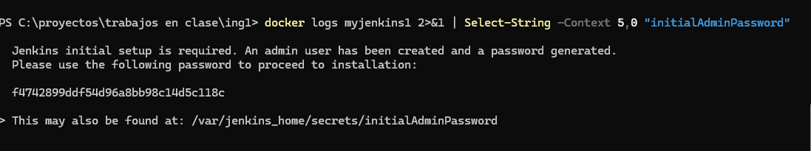
pswd: 78c6cf7ac011411085b2e5cb92731ca7
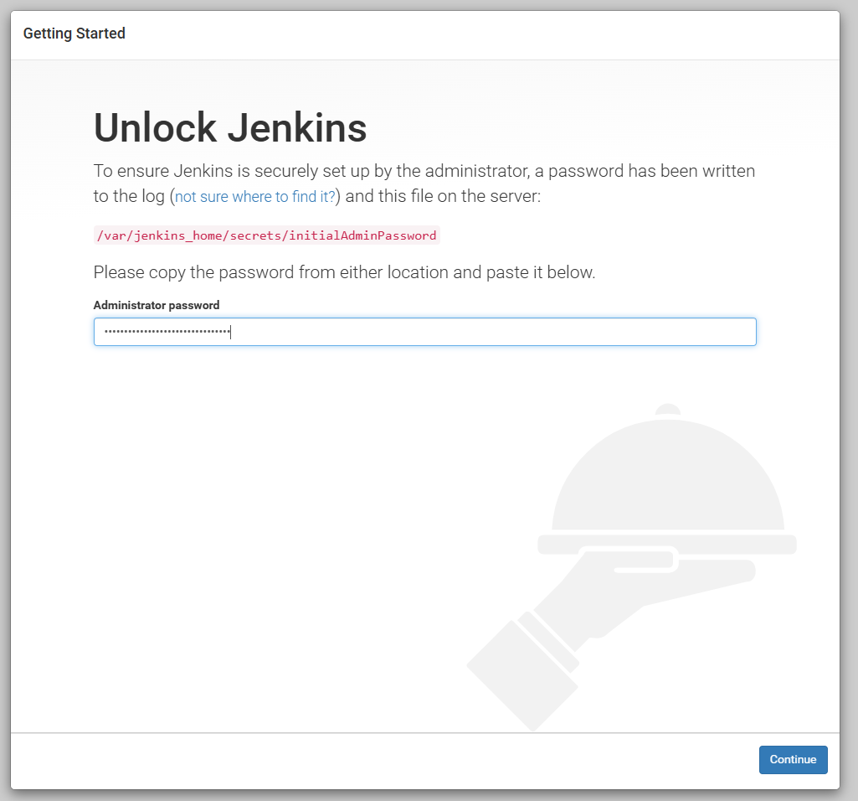

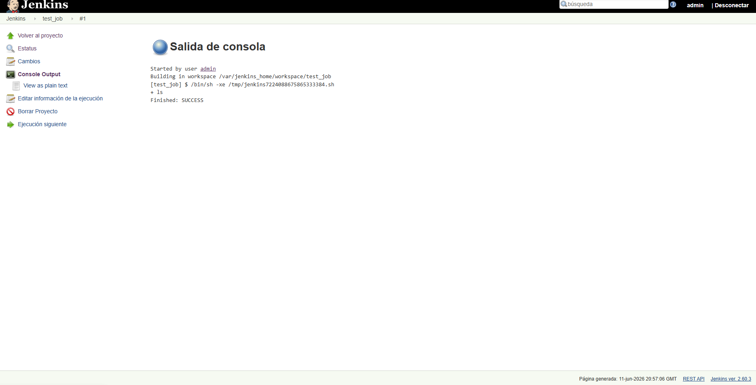
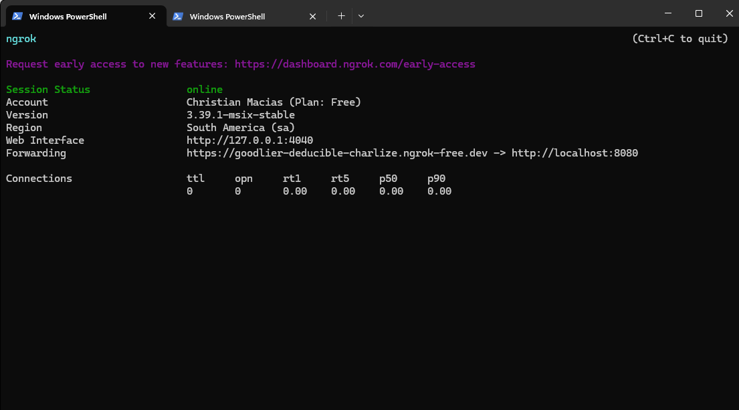

Diego Alfonzo Yagual
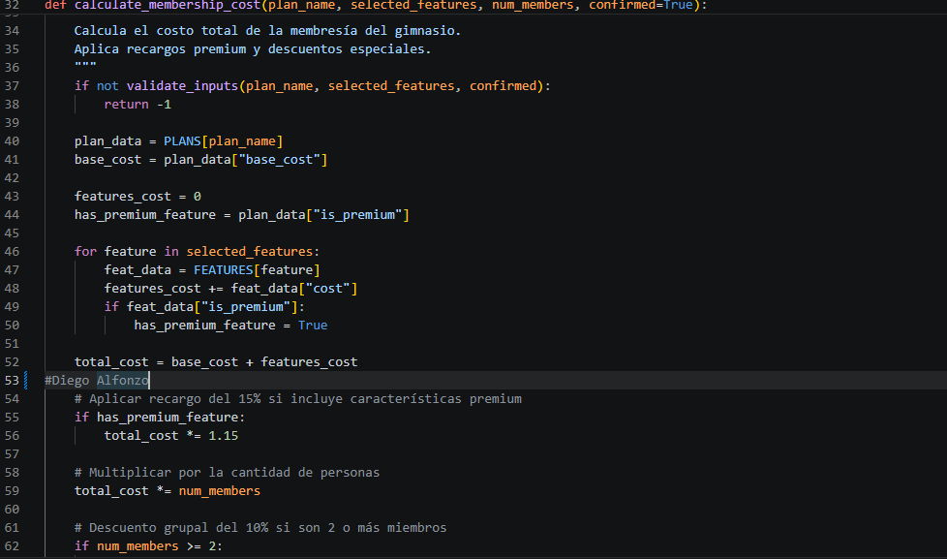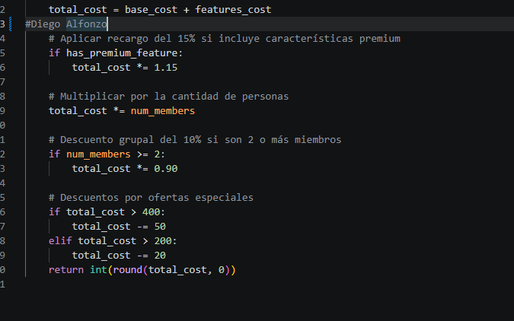

Jefferson Saltos
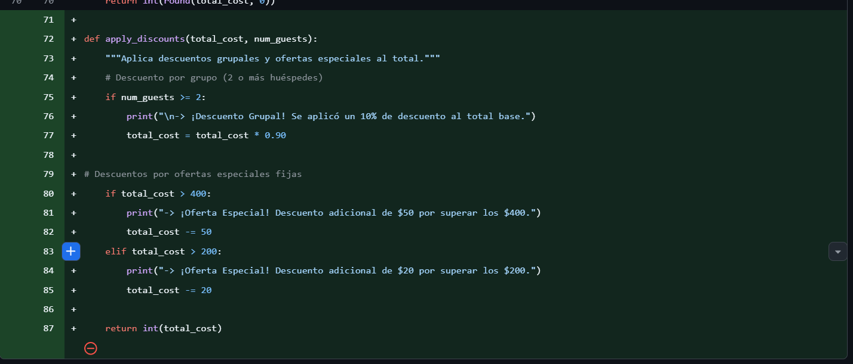

Ayman El Salous
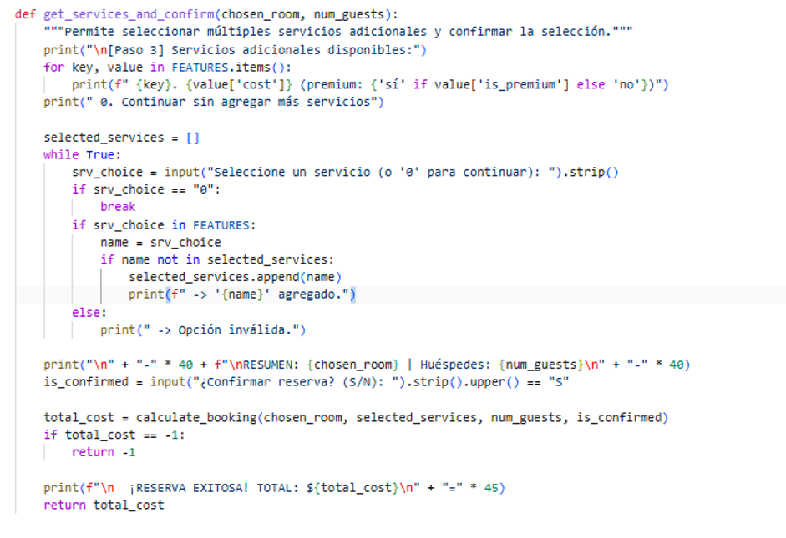
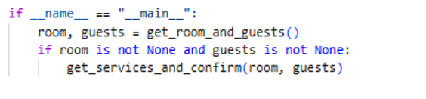

Test
Diego Alfonzo Yagual
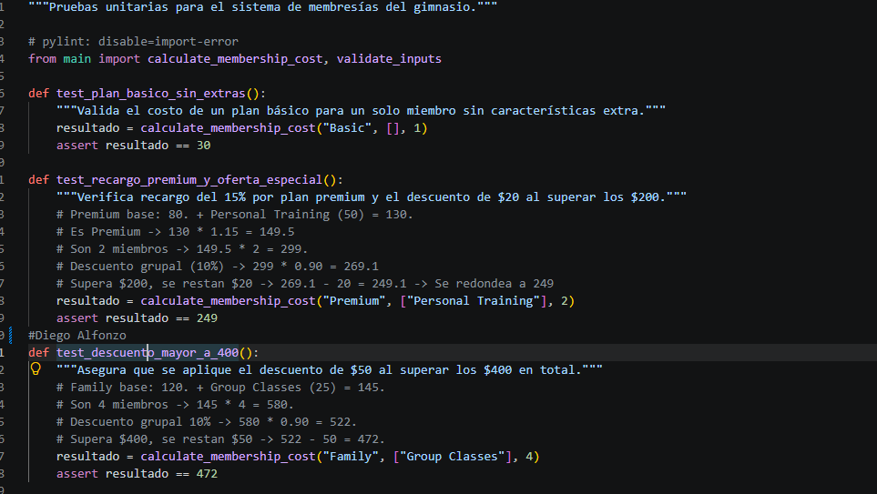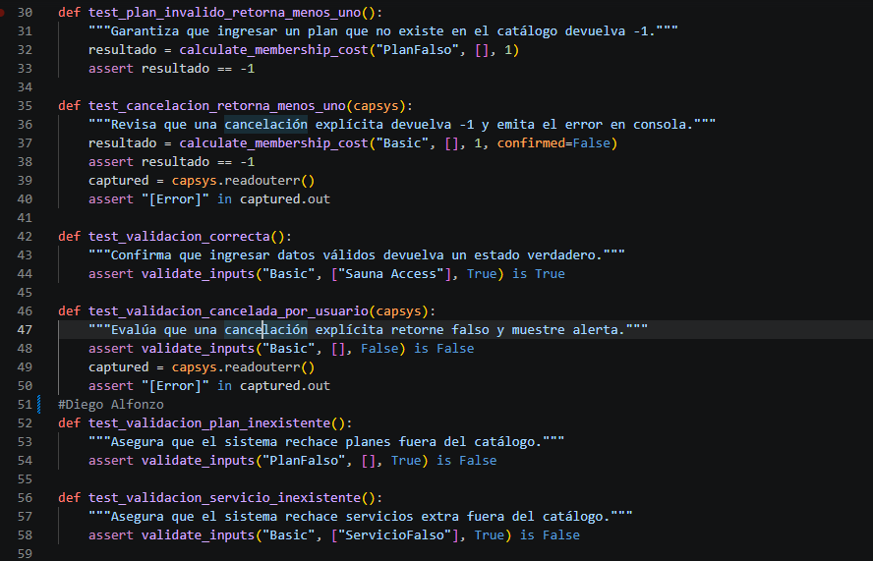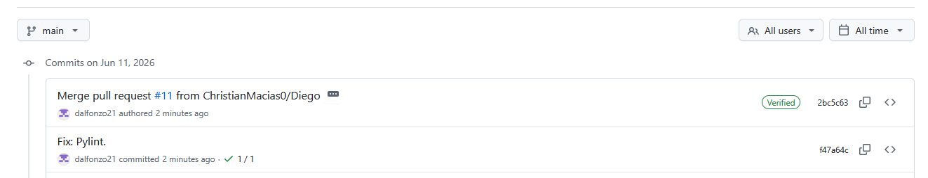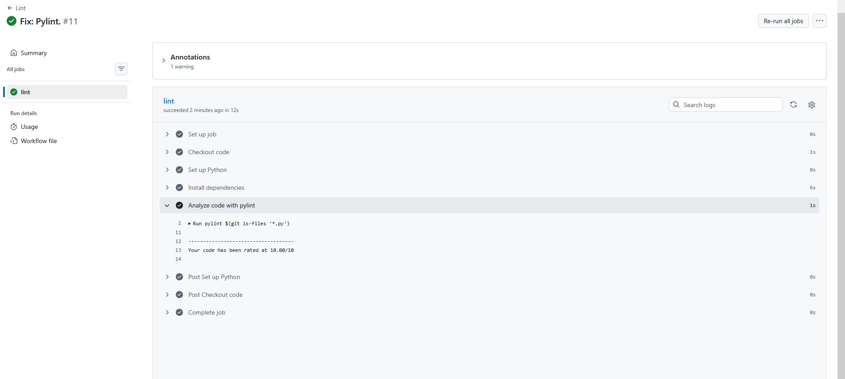
test Danilo Drouet
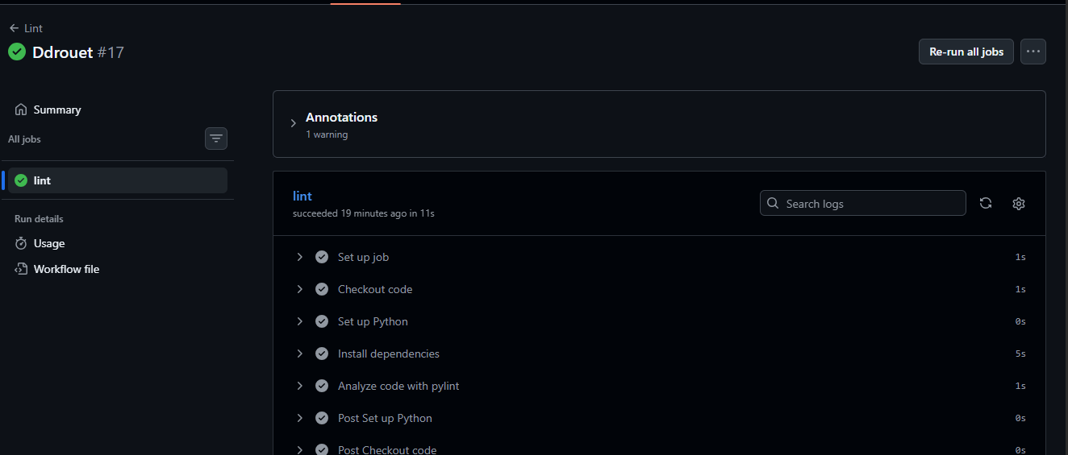

QUESTIONS

A.
Continuous Integration is a software development practice where developers frequently merge their code changes into a central repository. Once the code is committed, automated tools take over to automatically build the application and run automated tests against the new changes. The main goal is to detect and fix bugs as quickly as possible, ensuring that the main codebase remains stable and clean.

B.
In modern software development, continuous integration is essential for functional code that will go to production. Here is why:
- Early Bug Detection: Continuous Integration helps you catch errors within minutes of writing the code.
- Eliminates issues when integrating: When multiple developers work on a project without CI, combining their work at the end of a sprint is a nightmare. CI forces small, manageable integrations.
- Code will work everywhere: Because the code is built and tested in a clean, standardized cloud environment, it eliminates local environment discrepancies.
- Faster Time-to-Market: Automated testing reduces manual QA bottlenecks, allowing teams to deliver features to users much faster.

C.
While CI benefits almost any software project, it is highly recommended and practically mandatory for:
- Team-Based Projects: Any project with two or more developers. The larger the team, the more critical CI becomes to prevent code overwrites.
- Agile and Scrum Projects: Projects that require frequent updates, quick iterations, and continuous delivery of value.
- SaaS and Web Applications: Platforms that need to deploy updates daily or weekly without causing downtime.
- Large-Scale or Long-Term Projects: Systems where manual testing would take days or weeks to complete for every minor change.

D.
The "Integration Hell" Effect: Teams spend days, or even weeks, manually resolving massive merge conflicts and broken dependencies before a release.
- High Bug Rates in Production: Without automated testing on every commit, critical bugs inevitably slip through to the end-users.
- Slower Development Velocity: Developers become afraid to change code because they don't know what might break, slowing down the entire project.
- Lack of Visibility: Project managers and stakeholders have no real-time data on whether the current version of the software actually works.

E.
- Supporting Iterative Delivery: Agile relies on delivering working software in short sprints. CI ensures that at the end of every sprint (or even every day), the software is in a deployable state.
- Accelerating Feedback Loops: Agile thrives on quick feedback. CI provides immediate feedback to developers on whether their latest feature broke existing functionality.
- Enhancing Collaboration: Agile promotes shared ownership of the codebase. CI gives the team confidence to collaborate on the same files because the automated guardrails prevent them from breaking each other's work.
- Embracing Change: Agile means requirements change frequently. CI gives teams the flexibility to refactor and change code safely, knowing the automated test suite will catch any regressions.

Conclusions
- Guardrails Prevent Regression: Automated unit testing via pytest successfully isolated algorithmic and logical deficiencies before the code reached deployment stages.
- Standardized Linters Enforce Quality: Pylint acts as an objective quality gate. Forcing developers to clear trailing spaces and write docstrings dramatically enhances code readability, maintainability, and long-term project viability.
- Automation Mitigates Integration Hell: Automated pipelines break down massive release bottlenecks into micro-integrations, providing instantaneous feedback metrics directly linked to Git pull requests.

Recommendations
- Enforce Strict Local Hooks: Developers should configure local pre-commit hooks containing linting tools to avoid triggering remote CI builds that fail due to simple stylistic errors like trailing whitespaces.
- Parameterize Testing Environments: Use testing tools like tox or matrix builds within Jenkins to test the codebase against multiple Python versions concurrently.
- Migrate Tunnels to Cloud Infrastructure: While ngrok works seamlessly for local testing workshops, production pipelines should be hosted on a cloud-based infrastructure (e.g., AWS, Docker containers) to ensure high availability and stability.

References:
[1] Amazon Web Services, «What is Continuous Integration?». [En línea]. Available: https://aws.amazon.com/devops/continuous-integration/
[2] Jenkins, «How to Install Jenkins on Windows». [En línea]. Available: https://www.jenkins.io/doc/book/installing/windows/
[3] GitHub Docs, «Configuring Workflows». [En línea]. Available: https://docs.github.com/es/actions/using-workflows
[4] Atlassian, «Continuous integration: What it is and why you need it». [En línea]. Available: https://www.atlassian.com/continuous-delivery/continuous-integration
[5] Red Hat, «What is CI/CD?». [En línea]. Available: https://www.redhat.com/en/topics/devops/what-is-ci-cd
[6] Learn X in Y Minutes, «YAML Basics». [En línea]. Available: https://learnxinyminutes.com/docs/yaml/

